**Spatio-Temporal Characterization of Pinniped Strandings and Human Interaction Cases in the Pacific Northwest, 1991 - 2016**

Amanda J. Warlick,1 Deborah A. Duffield,2 Dyanna M. Lambourn,3 Steven J. Jeffries,3 James M. Rice,4 Joseph K. Gaydos,5 Jessica L. Huggins,6 John Calambokidis,6 Lesanna L. Lahner,7 Jennifer Olson,8 Erin D'Agnese,9 Victoria Souze,10 Alysha Elsby,10 and Stephanie A. Norman11

*1. ECS Federal, LLC, Seattle, WA 98115, USA E-mail: amandajwarlick@gmail.com*  
*2. Biology Department, Portland State University, Portland, Oregon 97207, USA*  
*3. Washington Department of Fish and Wildlife, Marine Mammal Investigations, Lakewood, Washington, USA*  
*4. Marine Mammal Institute, Oregon State University, Newport, Oregon 97365, USA*  
*5. SeaDoc Society, UC Davis Karen C. Drayer Wildlife Health Center–Orcas Island Office, Eastsound, Washington 98245, USA*  
*6. Cascadia Research Collective, Olympia, Washington 98501, USA*  
*7. SR3: Sealife Response, Rehab, and Research, Seattle, WA 98275, USA*  
*8. The Whale Museum, Friday Harbor, WA 98250, USA*  
*9. University of California, Davis, School of Veterinary Medicine, Davis, California 95616, USA*  
*10. Whatcom Marine Mammal Stranding Network, Whatcom, Washington USA*  
*11. Marine-Med: Marine Research, Epidemiology, and Veterinary Medicine, Bothell, WA 98021 USA*

**Abstract**

Pinniped strandings can be used as a proxy to evaluate the impacts of anthropogenic activities on the local marine environment. Stranding data from Oregon and Washington 1991-2016 were used to examine regional and temporal patterns in strandings and human interaction cases across age and sex for six species. Over the study period, 14,729 pinnipeds were reported stranded along the coast in the Pacific Northwest, 11% of which were documented as human interaction cases. Total strandings and the number of reported human interaction cases increased over time for most species. The composition of age and sex classes varied for each species, as did the proportion of strandings identified as human interaction cases. Gunshot wounds and fisheries entanglements were concentrated in clusters along the coast and together constituted the majority of human interaction cases. Stranding and human interaction case hotspots were different across species and varied seasonally, likely due to the distribution of pinnipeds and human activities along the coast. Despite the challenges and uncertainties inherent in using stranding data as an indicator of pinniped health and anthropogenic impacts, modeling spatio-temporal patterns is useful for stranding response practitioners and natural resource managers when evaluating the scope and magnitude of threats to pinniped populations.

**Key Words:** pinnipeds, stranding, human interactions, spatio-temporal analysis, Pacific Northwest, anthropogenic impacts

**Introduction**

Pinnipeds are subject to a wide range of natural and human-related causes of illness or injury, and studying the spatio-temporal patterns of pinniped strandings can provide insight into the dynamic and interconnected factors influencing the health of populations vulnerable to human activities. Pinnipeds are often considered sentinels of ocean health (Ross, 2000; Aguirre & Tabor, 2004; Bossart, 2006, 2011; Moore, 2008), as they are top predators living at the land-sea interface and strand onshore exhibiting direct evidence of the threats they encounter in their environment. However, factors influencing where and when an animal strands are diverse, numerous, and interdependent, including ocean conditions, prey availability, susceptibility to disease, and changes in abundance, pupping season, or species range (Woodhouse, 1991; Brabyn & McLean, 1992; Wilkinson & Worthy, 1999; Norman et al., 2004; Pyenson, 2010; Osinga et al., 2012; Berini et al., 2015; Johnston et al., 2015). Stranding records can therefore provide insight into pinniped life history traits and behavioral responses to natural environmental fluctuations and human-related activities. For instance, strandings of both pinnipeds and cetaceans have been found to correlate with prevailing ocean conditions, changing species abundance and distribution, and greater reporting effort (Norman et al., 2004; Leeney et al., 2008; Pikesley et al., 2012; Berini et al., 2015; Huggins et al., 2015a; Prado et al., 2016). Increased stranding events for seals in the northeast U.S. (Soulen et al., 2013; Johnston et al., 2015) and the Netherlands (Osinga et al., 2012) have also been attributed to a combination of these factors.

On the U.S. West Coast, researchers have extensively studied stranding trends in California sea lions (*Zalophus californianus*), northern elephant seals (*Mirounga angustirostris*), and harbor seals (*Phoca vitulina*) in central California and generally found that strandings and documented human interaction cases (*e.g.*, fisheries entanglements, gunshot wounds, dog bites, etc.) have increased over time, that males and pups strand in greatest numbers, and that strandings have been elevated during El Niño events (Stewart & Yochem, 1987; Goldstein et al., 1999; Greig et al., 2005; Melin et al., 2000, 2008, 2010; Moore et al., 2009; Keledjian & Mesnick, 2013). In the Pacific Northwest, researchers have used stranding data to identify trends in mortality rates and causes, primarily for harbor seals (Stroud & Roffe, 1979; Huggins et al., 2013; Lambourn et al., 2013). Norman et al. (2004) identified cetacean stranding hotspots in the Pacific Northwest and noted a summer peak in reported strandings likely due to the seasonal rise in beach attendance and a greater cetacean presence in the area during periods of stronger inshore upwelling. Patterns in harbor porpoise (*Phocoena phocoena*) and killer whale (*Orcinus orca*) strandings have been used to examine long-term mortality trends and highlight the importance of consistent stranding response effort and data collection protocols in the region (Barbieri et al., 2013; Huggins et al., 2015a). However, few spatio-temporal analyses have been conducted on long-term pinniped stranding patterns in the region.

Data from stranding response networks were used to characterize spatio-temporal trends in age, sex, species, and human interaction cases for stranded pinnipeds in Oregon and Washington from 1991-2016, a longer time period than has been assessed to date. We hypothesized that the number of reported strandings and human interaction cases will have risen over the study period due to a combination of growing populations, range expansion, and the enhanced stranding response capacity that began in the mid-2000s. We also expected that strandings for different species would not be uniformly distributed along the coast. This study provides summary statistics that can be used to help allocate limited resources for pinniped stranding response and to guide further investigations into the complexities of co-occurring human and pinniped uses of a diverse and changing coastal landscape.

The quantity and consistency of information contained within stranding records can vary over time and across regions, particularly in an area such as the Pacific Northwest that is characterized by diverse topography (including remote beaches) and a large number of stranding response groups. Stranding response relies heavily on reports from the public, which can vary by region due to the degree of residential development, public awareness, and community interest (Huggins et al., 2015b). This heterogeneity illustrates the importance of acknowledging and contextualizing the variability inherent in stranding data when studying the natural and anthropogenic threats facing pinniped populations. Despite these caveats, stranding records are often the best or, on occasion, the only available data for evaluating population-level threats. Analyses of stranding data are critical to natural resource managers tasked with assessing and monitoring pinniped populations and are additionally useful to ensure that response network practitioners have the necessary resources to study, collect, and evaluate stranded marine animals.

*Study Area and Species*  
The coastline of the U.S. Pacific Northwest is a patchwork of varied landscapes (*e.g.*, rocky intertidal zones, sandy beaches, estuarine embayments), public accessibility, and degree of development (*e.g.*, residential and commercial districts, shipping channels, ports, fishing activities, state and national parks, ecotourism). Dense human population areas include Astoria, Newport, and Coos Bay in Oregon, and cities along Puget Sound such as Seattle and Tacoma in Washington. Larger fishing ports include Astoria, Newport, and Seattle, and vessel activity is more common throughout inland Washington waters, Willapa Bay, and along the Columbia River. The coastlines along northern Washington and southern Oregon are less developed. Six pinniped species inhabit the coastal and inland waters of Oregon and Washington for some or all of their lives. Each are distinguished by unique life history characteristics, behavioral traits, local abundance, and dynamic population trends that influence their presence within the study area, and therefore, when, where, and how often they strand.

Harbor seals are the most abundant and widely distributed pinniped in Washington State waters and are found along the entire West Coast (Jeffries et al., 2000). Four stocks (three inland, one coastal) have been delineated within the Pacific Northwest (Huber et al., 2012; Carretta et al., 2016), all of which are presumed to have stabilized and reached carrying capacity (Jeffries et al., 2003). Reproductive cycles vary regionally, with pupping occurring in late spring along the Oregon coast, mid-May through June for the outer Washington coast, and July through August in inland Washington waters (Jeffries et al., 2000). Adult harbor seals exhibit high haul-out fidelity and choose sites depending on the time of day, tides, season, or food availability (Thomas et al., 2011; London et al., 2012).

California sea lions are the most abundant pinniped off the coast of California, numbering nearly 300,000 individuals and growing approximately 5.4% per year (Carretta et al., 2016). The majority of the population breeds on the Channel Islands off southern California with smaller rookeries off the coast of Baja California. While non-lactating females disperse throughout California, lactating females remain near the rookeries during the summer and fall, making shorter local foraging trips until pups are weaned the following spring (Melin et al., 2008). Adult and subadult males make winter foraging trips as far north as southeast Alaska and return south in late spring (Lowry & Forney, 2005). Individuals found in the Pacific Northwest are therefore usually males utilizing feeding areas in fall, winter, and spring months, though small numbers of females have been sighted in the area and even into Alaska in recent years (Maniscalco et al., 2004, WA Dept. of Fish & Wildlife, *unpub. data*).

Steller sea lions (*Eumetopias jubatus*) range from Japan throughout the North Pacific and south into California. The Eastern distinct population segment has breeding and haul-out sites located along the coast of southeast Alaska, British Columbia, Washington, Oregon, and California (DeMaster, 2014; Carretta et al., 2016). Population dynamics vary by region, with overall growth rates estimated at 2.5%-4.7% per year. During the summer breeding season, adult males generally remain onshore while females and juveniles make short foraging trips (National Marine Fisheries Service [NMFS], 2013). Otherwise, individuals are widely dispersed, particularly males and subadults (Carretta et al., 2016).

Northern elephant seals range from Mexico to the Aleutian Islands, making seasonal migrations from rookeries in California to feeding areas in Alaska and the central North Pacific (Zenkovich, 1998; Carretta et al., 2016). The population has grown by 3.8% per year in recent decades (Lowry et al., 2014). Males make spring and fall feeding trips and females make an initial two-month foraging trip after weaning pups in late winter and then another eight-month foraging trip during gestation before returning to the rookery to give birth and breed in winter (Le Boeuf et al., 2000). In the Pacific Northwest, individuals (largely subadults) can be found hauled out during molting from March through August (Carretta et al., 2016).

Northern fur seals (*Callorhinus ursinus*) range from southern California far into the North Pacific, with two recognized stocks in U.S. waters: California and Eastern Pacific (Carretta et al., 2016). Primary rookeries are located on the Pribilof and Bogoslof Islands in the Bering Sea, though individuals may haul out along the coast in the Pacific Northwest or British Columbia outside of the breeding season (Gelatt et al., 2015). Adults are onshore throughout the summer breeding season and then remain at sea for seven to eight months, with females and pups from both stocks migrating to foraging areas off the West Coast (Lea et al., 2009; Orr et al., 2012).

Guadalupe fur seals (*Arctocephalus townsendi*) were presumed extinct in the late 1800s but were then sighted again beginning in 1928 off Baja California (Townsend, 1931). The population is listed as Threatened under the Endangered Species Act (ESA) but has been rebuilding, increasing by 13-21% per year (Esperon-Rodriguez & Gallo-Reynoso, 2012). Less is known about seasonal distribution and foraging patterns, but individuals have been sighted in the Channel Islands and off the coasts of Washington and British Columbia, and strandings have been occurring in Oregon and Washington, suggesting potential re-expansion into their historic range that spanned central and southern California (Hanni et al., 1997; Lambourn et al., 2015).

**Methods**

*Data Sources and Characterization*  
Data for this analysis were drawn from the National Marine Fisheries Service national stranding database (last accessed February 2017) that contains standardized “Level A” data from more than 15 contributing response network members spanning the coasts of Oregon and Washington (Supplemental Figure S1). Database entries include an ID number, observation date, stranding location, latitude and longitude coordinates, age, sex, species, stranding condition (live or dead), and other observational comments including evidence of injury or human interaction. Data are collected by network members and submitted to the national database throughout the year, and generally finalized by NOAA by March of the following year. Records for all pinnipeds reported stranded in Oregon and Washington from 1991 to 2016 (*n* = 14,729 records) were aggregated by month, year, and stranding location. Age class designations[1] were included on the Level A form beginning in the early 2000s, and we therefore only analyzed age class data from 2002-2016 (*n =* 10,861). Summary statistics were derived for three regions (Oregon coast, Washington coast, inland Washington waters) because stranding response, beach accessibility, and species' habitat use in these areas are very different. For this analysis, we used the reported stranding location as a relative approximation for where strandings and human interactions actually took place, though carcasses can drift for some time before making landfall, and entangled animals can migrate with entangling debris from a different region.

In addition to investigating total stranding cases, we examined the number of cases indicating the presence of human interaction (HI). Human interaction cases are recorded on the Level A stranding intake form as "Yes," "No," or "could not be determined (CBD)," including designations for fisheries entanglements,[2] gunshot wounds, boat collisions, or "other" human interactions. Descriptions of "other" human interactions can include indeterminate blunt trauma, dog bites, debris entanglement, oil staining, and humans harassing or illegally picking up or relocating animals. The “CBD” designation applies to a variety of situations, including instances when an animal was not examined or when an examiner was unable to confidently determine the presence or absence of HI. Thus, the number of confirmed HI cases is a conservative estimate. Records for dead or decomposed animals can be missing specification in certain fields, resulting in "Unidentified" age, sex, or even species designations.

Two measures of the prevalence of HI cases were examined: (1) the annual proportion of total strandings made up of HI cases (*e.g.*, number of fisheries entanglements divided by total stranding cases) to reveal variation in the magnitude of HI independent of changes in population demographics, and (2) the percent composition of HI cases (*e.g.*, number of fisheries entanglements divided by total HI cases) to examine which type(s) of anthropogenic activity may have a greater effect on a given age, sex, or species. It is important to note, however, that stranding response networks with the capacity to conduct more detailed necropsies may report a higher proportion of positive HI findings, while those that conduct fewer or less detailed necropsies may report a higher proportion of CBD determinations. Therefore, results examining the spatial differences in the prevalence of HI cases must be interpreted within this context.

*Statistical Analysis*  
To determine whether the number of strandings was significantly different across categorical variables such as age class, sex, species, or location, we conducted pairwise Kruskal-Wallis Nemenyi tests (`posthoc.kruskal.nemenyi.test` function in the PMCMR package) in R (R Development Core Team, 2009) with age class, sex, and species as independent variables and the number of stranding cases as the dependent variable. Summary statistics were examined both at the regional level (*i.e.*, by state) for management-relevant analyses and on a local level (*i.e.*, by county) more useful for stranding response practitioners.

To determine whether strandings and HI cases have changed over the study period, we examined both the *number* and *prevalence* over time. We used negative binomial general linear model (GLM) regressions for total annual stranding cases against year (`glm.nb` function in the MASS R package) to account for overdispersion and correct for standard error estimates that might be biased in a Poisson regression model. Regressions were repeated for total strandings and HI cases for each species. Regression coefficients reported using this technique were back-transformed, resulting in a "fold increase" (*e.g.*, y = 1.051x being equivalent to a 5.1% increase per year). To examine changes in the prevalence of HI cases, we used a binomial logistic GLM regression with the logit link function, resulting in untransformed regression coefficients. Annual time series trends were also explored using Chow's breakpoint test (`sctest` function in the strucchange R package) to determine whether interannual changes in stranding counts reflect known changes in stranding network capacity, response effort, or funding over time. To determine whether strandings exhibited seasonal patterns, post-hoc pairwise Kruskal-Wallis Nemenyi tests were used with month as the independent variable and total monthly stranding cases as the dependent variable. Monthly analyses were conducted using only cases that were recorded as being either alive or freshly dead at the time of observation in order to best capture the temporal component of the stranding event.

To determine possible spatial patterns in overall strandings and HI cases, the negative binomial GLM regression and pairwise Kruskal-Wallis Nemenyi tests were applied using stranding location (county) as the independent variable and annual stranding cases as the dependent variable. Stranding hotspot maps were generated with a kernel density estimation (Gatrell et al., 1996) with three and four bins (`geom_density2d` function in the ggplot2 R package). This function does not account for the fact that strandings occur only on the coast, so these maps are intended as a qualitative visualization rather than a statistical predictor.

*Caveats*  
A pinniped is defined as being stranded when it is either dead or still alive on the beach and in need of medical attention or unable to return to the water on its own (Marine Mammal Protection Act of 1972). Animals are also reported by the public when they might be simply resting or molting, and responders frequently monitor these situations (particularly if the animal is located in a populated area) and use their best judgment about whether to document it in the database. Therefore, reported strandings for some species in some areas (particularly for elephant seals and harbor seal pups in inland Washington waters) may over-represent the true number of stranded animals that are sick or injured.[3] We have not excluded these in this analysis because such cases are inconsistently documented across stranding networks and are therefore difficult to systematically extract from such a large data set. Furthermore, they represent the true number of cases that require time and resources from response networks.

Stranding response networks in Oregon and Washington are diverse and have grown in their capacity over the study period, particularly in the early 2000s with the implementation of the John H. Prescott Marine Mammal Rescue Assistance Grant Program,[4] which could in part account for a rise in reported strandings. One of the challenges of using data from this compilation of stranding networks is that beach coverage, response capacity, and even data-reporting protocols vary between network members, over time, and across regions (Huggins et al. 2015b). However, when combined, these data illustrate what is known and what remains uncertain about long-term spatio-temporal patterns in strandings and HI cases throughout the region.

**Results**

From 1991-2016, local stranding response networks identified and recorded 14,729 stranded pinnipeds along the coasts and inland waters of Oregon and Washington. Approximately 29% (*n* = 4,288) were alive and 31% (*n* = 4,611) were freshly dead at the time of recovery, with the remainder being in various states of decomposition. The majority of total strandings over the study period were harbor seals (60% of all cases) and California sea lions (19%), followed by smaller numbers of Steller sea lions (7%), northern elephant seals (3%), Guadalupe fur seals (1%), and northern fur seals (1%) (Table 1). Annual strandings were significantly different across species over the study period (*χ*2 = 9.8, *p* < 0.01), ranging from a median of 3 per year for northern fur seals to 335 per year for harbor seals (Figure 1a). The sex and age composition of strandings varied depending on species and can be obscured by the proportion of unidentified cases, though California sea lions exhibited a higher proportion of males relative to other species (Table 1).

Evidence of human interaction was noted in 11% (*n* = 1,652) of all stranding cases over the study period, with the greatest number being from "other" (*n* = 675, 40% of all HI cases), gunshot wounds (*n* = 623, 37%), and fisheries entanglements (*n* = 356, 21%), followed by a much smaller number of boat collision injuries (*n* = 79, 5%) (Figure 1b). Of these “other” cases, less than half of the records contain descriptions, and of those described cases, the majority were related to marine debris and public harassment followed by dog bites and illegal pick-ups. Fisheries interactions were the most common type of HI case for yearlings (40% of all yearling HI cases) and were less prominent for pups and adults (16%-18%) (Table 2). Gunshot wounds, however, were the most prominent HI type for adults (58% of adult HI cases) and subadults (52%), with very few gunshot cases in pups (4%). Boat collisions constituted a small proportion (4-7%) of HI cases for all age classes (Table 2). Similar to the pattern observed for total cases, harbor seals comprised the majority of HI cases (56%) followed by California sea lions (28%) and Steller sea lions (11%) (data not shown).

*Species*  
Harbor seals - Pups amounted to 61% of strandings (from 2002-2016), greater than that observed in any of the other species (Table 1). Harbor seals are the only species that stranded in greatest numbers in Washington, with 77% occurring along inland waters and much fewer (8%) on the outer coast (Table 3). Approximately 10% of strandings were HI cases, the majority of which (53%) were "other" cases (largely public harassment, illegal pick-ups, and dog bites). Gunshot wounds (21% of HI cases) and fisheries entanglements (20%) were also prominent, with few (6%) boat collision injuries (Table 3).

California sea lions - Approximately 78% of strandings were identified as male, 1% as female, 64% adult, and 11% combined pups and yearlings (Table 1). The majority of strandings (69%) occurred along the Oregon coast, with 19% in inland Washington waters and 12% along the Washington coast (Table 3). Almost 16% of strandings were HI cases, the majority of which (59%) were gunshot wounds. “Other” HI cases identified for this species were primarily related to marine debris. Just 3% of HI cases were boat collision injuries (Table 3).

Steller sea lions - Approximately 42% of strandings were identified as male and 34% as female, the remainder being unknown (Table 1). Similar to California sea lions, the majority (60%) of strandings were identified as adults, unlike other species where more were pups and yearlings (Table 1). The majority of strandings (67%) occurred along the Oregon coast with the remainder being equally divided between outer Washington coast and inland waters (Table 3). Approximately 18% of strandings were HI cases, second only to northern fur seals. The majority of HI cases were gunshot wounds (74%) followed by fisheries entanglements (15%), “other” (9%), and boat collision injuries (2%) (Table 3).

Northern elephant seals - Approximately 38% were identified as male and 14% female, with a relatively higher proportion of unidentified cases (Table 1). Similar to other species, the majority of strandings occurred along the Oregon coast (64%) (Table 3). Northern elephant seals had one of the lower proportions of HI cases (10%) across species. The majority (40%) of HI cases were categorized as "other" (but lacked further descriptive details), followed closely by gunshot wounds (30%) (Table 3).

Guadalupe fur seals – Approximately one-third of strandings were identified as male, female, and unknown sex, and the overwhelming majority of cases (92%) were identified as yearlings (Table 1). Similar to other species, the majority of strandings (60%) occurred along the Oregon coast, followed by the outer Washington coast (35%) and fewest in inland Washington waters (5%) (Table 3). Approximately 14% of strandings were HI cases (*n* = 24), the majority of which were fisheries entanglements (67%), followed by "other" cases that were not additionally detailed in the database (29%) (Table 3).

Northern fur seals - Northern fur seals exhibited the highest percentage of female strandings (41%) of any of the species, though there was also a large number of unidentified cases (Table 1). Approximately 75% of strandings were identified as pups and yearlings. Similar to other species, the majority of strandings (62%) occurred along the Oregon coast, followed by the outer Washington coast (25%) and fewest in inland Washington waters (13%) (Table 3). Just over 21% of strandings were HI cases, the highest proportion of any species. Similar only to Guadalupe fur seals, the majority of HI cases were fisheries entanglements (72%), followed by "other" (24%) (Table 3).

*Temporal Patterns*  
All stranding cases - Since 1991, the number of reported stranding cases increased significantly over time (y = 1.045x, z = 4.6, *p* < 0.001), with 2003 being identified as a breakpoint in the time series using Chow's test (F = 5.8, *p* < 0.01). An annual average of 341 individuals stranded per year throughout the 1990s up to 2002 and 792 per year since then. However, patterns in annual strandings varied for each species: significantly increasing for harbor seals (y = 1.045x, z = 4.6, *p* < 0.001), California sea lions (y = 1.077 x, z = 5.1, *p* < 0.001), Steller sea lions (y = 1.127 x, z = 6.9, *p* < 0.001), Guadalupe fur seals (y = 1.22 x, z = 2.5, *p* < 0.05), and northern fur seals (y = 1.048 x, z = 2.2, *p* < 0.05) (Figure 2). No significant change was detected for northern elephant seal strandings over time. Strandings of California sea lions notably spiked in 2009 and 2010 (Figure 2).

Human interaction cases - The total number of combined HI cases increased significantly from 1991-2016 (y = 1.07x, z = 5.1, *p* < 0.001) (Figure 3a). An annual average of 28 cases was documented per year throughout the 1990s up through 2002 and 98 per year since 2003. Specifically, there was an increasing number of gunshot wounds (y = 1.051 x, z = 2.8, *p* < 0.01), fisheries entanglements (y = 1.068 x, z = 5.9, *p* < 0.001), and boat injuries (y = 1.079 x, z = 3.1, *p* < 0.001) over the study period (Figure 3b). At the species level, the number of documented HI cases increased for harbor seals (y = 1.073 x, z = 4.9, *p* < 0.001), California sea lions (y = 1.075 x, z = 4.5, *p* < 0.001), Steller sea lions (y = 1.096 x, z = 4.8, *p* < 0.001), and Guadalupe fur seals (y = 1.11 x, z = 1.9, *p* < 0.05) (Figure 3a).

In addition to an increasing number of HI cases, the prevalence of HI cases (number of HI cases divided by total) also increased (y = 0.5x, z = 11.6, *p* < 0.001) and exceeded 20% in 2012, 2013, and 2015. The range and median prevalence varied across three time periods for each HI case type and for combined HI cases per species (Figure 4). At the species level, median annual proportions of HI were higher in the 2010s compared to the 1990s and/or 2000s for harbor seals (y = 0.6x, z = 6.6, *p* < 0.001) and northern elephant seals (y = 0.1x, z = 0.4, *p* < 0.1), and lower in the 2000s for California sea lions (y = -0.7x, z = -4.4, *p* < 0.001) (Figure 4a). For specific HI types, median annual proportions were higher since the 1990s and/or 2000s for fisheries entanglements (y = 0.34x, z = 2.4, *p* < 0.05), gunshot wounds (y = 0.3x, z = 3.1, *p* < 0.01), boat collisions (y = 1.7x, z = 3.4, *p* < 0.001), and “other” cases (y = 1.2x, z = 8.7, *p* < 0.001) (Figure 4b). More specifically, the prevalence of gunshot wound cases increased significantly over the study period for California sea lions (y = 0.02x, z = 1.9, *p* < 0.1) and decreased for harbor seals (y = -0.03x, z = -3.7, *p* < 0.001); the prevalence of fisheries entanglement cases increased for harbor seals (y = 0.03x, z = 3.1, *p* < 0.001) and decreased for northern elephant seals (y = -0.14, z = -3.0, *p* < 0.01); boat-related injuries increased for harbor seals (y = 0.08x, z = 3.3, *p* < 0.001); and "other" increased for California sea lions (y = 0.04x, z = 2.3, *p* < 0.05) and harbor seals (y = 0.001x, z = 9.0, *p* < 0.001) (data not shown).

A seasonal peak in total strandings was evident, though the timing of this peak was different across species (Figure 5a). Pairwise Tukey comparisons showed that harbor seal strandings were significantly higher June through September and that HI cases for the species were significantly higher in July (p < 0.05). Though not statistically significant, California sea lion strandings exhibited a peak in May and again from August through November. The different HI case types exhibited seasonal patterns (Figure 5b) and these depended on region (Figure S2). For example, boat collision cases only occurred from April to October in inland Washington waters and were highest in August. Fisheries entanglements were highest in May and June in Oregon and highest in August in inland Washington waters. Gunshot wound cases exhibited a discrete peak in March on the outer Washington coast when they accounted for 12% of all monthly cases (as opposed to less than 3% the rest of the year). Gunshot wounds were highest in August in inland Washington waters and from April-June and September-October in Oregon.

*Spatial Patterns*  
Over the study period, a higher number of strandings occurred along inland Washington waters and along the Oregon coast compared to the outer Washington coast. The proportion of total annual strandings occurring in Oregon ranged from 13% to 55%, averaging 34% over the whole study period. The proportion of annual strandings occurring along the outer Washington coast ranged from 1% to 29%, averaging 9% over the whole study period. The proportion of annual strandings occurring along the shores of inland Washington waters ranged from 27% to 84%, averaging 57% for the whole study period. At a finer spatial scale, stranding hotspots differed across species, with harbor seal strandings primarily concentrated throughout inland Washington waters while other species stranded more along the coast (Figure 6). These hotspots remained relatively constant across the seasons of the year.

The distribution of HI cases between the three coastal regions was similar to that of overall strandings, with 33% of all HI cases occurring in Oregon, 50% in inland Washington waters, and the remaining 17% along the outer Washington coast. Human interaction hotspots generally overlap with overall strandings, though for some species there were additional HI hotspots or HI cases were more concentrated compared to overall strandings (Figure 6, Figure S1, Tables S1 & S2). For example, northern elephant seal HI cases were centered farther north than overall strandings and exhibited an additional hotspot in inland Washington waters. Harbor seal and California sea lion HI cases were denser near the mouth of the Columbia River where there was not a cluster for overall strandings. Human interaction cases for both Steller sea lions and Guadalupe fur seals were more concentrated around the mouth of the Columbia River relative to the distribution of overall strandings (Figure 6).

The distribution HI case types was different between the three regions. Boat collision injuries and fisheries interactions largely occurred throughout inland Washington waters and around the mouth of the Columbia River, while the only hotspot for gunshot wounds was centered around the Columbia River (Figure 7). These hotspots do shift seasonally: boat collision cases were most dense in inland Washington waters in the summer and on the coast during winter while fisheries and gunshot wound cases were only concentrated near Newport, OR during the spring but in Puget Sound the rest of the year (Figure S2).

**Discussion**

Our results identify and describe spatio-temporal stranding hotspots for pinnipeds in Oregon and Washington from 1991-2016. Harbor seals were the most commonly stranded species in inland Washington waters while other species stranded more frequently in Oregon. Age class and sex composition varied by species and a summer stranding peak was evident for harbor seals. The number of strandings and HI cases have increased over time for most of the species, though the prevalence of HI cases varied over time. Stranding and HI hotspots varied for each species and HI type, indicating spatio-temporal heterogeneity in strandings and human impacts.

Spatio-temporal patterns in pinniped strandings in Oregon and Washington are different for each of the six species, largely influenced by their unique life history characteristics that determine when, where, and how many animals occur -- and therefore strand -- along the coast. For example, the majority of California sea lion strandings were identified as male and occurred in May as well as the fall, reflecting the fact that males are making foraging migrations through the area while females largely stay close to the rookeries in California (Lowry & Forney, 2005; Melin et al., 2008). Though adults comprised a higher proportion of California sea lion strandings in our data, previous studies found that young animals were the most prominently stranding age class (Greig et al., 2005; Goldstein et al., 1999; Hanni & Pyle, 2000; Kaplan Dau et al., 2009), likely due to the presence of young animals around rookeries in California compared to the older animals foraging and migrating throughout the Pacific Northwest. Similarly, the prevalence of harbor seal pup strandings in inland Washington waters can be attributed to the overlap of haul-outs, rookeries, and dense human population areas that could lead to higher reporting rates or mother/pup separation. Further analysis of known haul-outs (Jeffries et al., 2000) and proxies for prey availability for each species could elucidate the connections between strandings and the seasonal use of important reproductive and foraging habitat at a finer spatio-temporal scale.

Pinniped species’ life history traits not only impact general stranding patterns, but also influence their likelihood of becoming entangled, shot, or struck by a vessel (*e.g.*, species such as northern fur seals that forage further offshore might be least likely to encounter vessel traffic and those whose foraging overlaps with a particular fishing area might have a higher prevalence of entanglements). In this study, northern fur seals, Steller, and California sea lions had the highest prevalence of HI cases, similar to others that have found these species to have relatively high prevalence of entanglement (Fowler, 1987, Delong et al., 1990; Kiyota & Baba, 2001; Greig et al., 2005; Antonelis et al., 2006; Kaplan Dau et al., 2009; NOAA, 2014). The average prevalence of HI cases for all species over the study period was approximately 11%, similar to that observed by others (Goldstein et al., 1999; Kaplan Dau et al., 2009; Moore et al., 2009; Bogomolni et al., 2010; Keledjian & Mesnick, 2013).

Not only was the prevalence of overall HI cases different across species, but the composition of HI cases varied as well. California and Steller sea lions were most affected by gunshot wounds compared to other human-related stranding causes (59% and 74% of HI cases, respectively), possibly due to the higher proportion of adults in the study area that might be more likely to be foraging in fishing areas or depredating fish. Fisheries entanglements, on the other hand, made up a lower proportion of HI cases for California and Steller sea lions, despite high entanglement rates being recorded in studies off the coast of California (NOAA, 2014). However, fisheries entanglements did comprise the majority of HI cases for Guadalupe and northern fur seals, similar to studies reviewed by NOAA (2014). Anecdotal observations made by response practitioners and haul-out surveys suggest that each species is affected by different types of entangling materials, including those not systematically assessed here (packing bands, ropes, etc.) as they fall into the “other” HI category on the Level A form. In Oregon, plastic packing bands and rubber bands (likely from fish bait boxes and crab pots) account for most California sea lion and Steller sea lion entanglements, respectively, while trawl nets are the most prominent in northern fur seal entanglements (NOAA, 2014; *pers comms*, J. Rice, 2017). Harbor seals and northern elephant seals were most affected by “other” human-related injuries, which included public harassment, debris entanglement, illegal pick-ups, and dog bites for those species. These observed patterns are likely a combination of the animals' behavioral ecology and the spatio-temporal distribution of human activities. However, as noted above, the prevalence and composition of HI cases can also be influenced by the ease of identifying the HI injury and the level of examination each species typically receives (*i.e.*, ESA-listed and infrequently stranded species such as northern fur seals might garner greater scientific interest and therefore more extensive examinations that would reveal evidence of human interaction).

*Temporal Patterns*  
Total annual reported strandings significantly increased over the study period, though this pattern was different for each species (Figure 2). Rather than being symptomatic of declining pinniped population health, the increasing number of reported strandings likely reflects growing abundance and enhanced capacity from the Prescott Grant Program that facilitated consistent reporting protocols and more responders covering beaches, as noted by Huggins et al. (2015a). Additionally, it is important to note that increasing trends are likely not linear over time but are instead driven by spikes in strandings, such as the heightened strandings of California sea lions observed in Oregon in 2009-2010, possibly due to a combination of an outbreak of leptospirosis, poor foraging conditions in California, and increased competition with fisheries (*pers comms,* D. Duffield, 2017). Seasonally, the summer peak in harbor seal strandings occurred during the pupping season, which varies by region. Dedicated summer surveys of harbor seal haul-outs could also have contributed to these elevated seasonal strandings.

The number of HI cases increased over the study period for harbor seals, California sea lions, Steller sea lions, and Guadalupe fur seals, mirroring the rise in overall strandings. These changes in the number of certain types of cases for certain species are likely the product of both endogenous factors (those related to the animals and their environment) and exogenous factors (human activities, policies, pollution events). The prevalence of gunshot wounds increased for California sea lions and the prevalence of fisheries entanglements increased for California sea lions and harbor seals. It is difficult to identify possible explanations for these observed trends as both pinniped populations and human activities can be simultaneously changing, additionally complicated by the fact that our ability to detect certain injuries or illnesses has also improved (Gulland & Hall, 2007). Despite the dearth of consistent data over time and space, interannual changes in the number or prevalence of HI could in theory be compared to proxies for fishing effort or other human activities in the future.

*Spatial Patterns*  
The distribution of strandings can be largely explained by the local abundance and demographic characteristics of each species. Stranding hotspots reported here are similar to those previously identified for cetaceans and pinnipeds in the area (Norman et al., 2004; Lee, 2016). In Washington, harbor seals primarily stranded throughout inland waters due to the area having a large number of haul-outs, rookeries, and higher public reporting. In contrast, fewer strandings were reported along the outer Washington and southern Oregon coasts, likely due to the fact that many beaches are isolated or inaccessible. Approximately two-thirds of Steller sea lion strandings occurred in Oregon, likely due to the three large breeding sites along the coast. Guadalupe fur seal strandings were most concentrated at the mouth of the Columbia River and into Willapa Bay and Grays Harbor on the outer coast, likely reflecting the fact that few individuals range into inland Washington waters given their highly pelagic nature. Similarly, northern fur seal strandings did not exhibit hotspots in inland Washington, possibly due to individuals spending more time near rookeries in Alaska or foraging offshore. These results align with findings from other coastal areas where patterns in marine mammal strandings reflect species' local abundance or seasonal distribution (Woodhouse, 1991; Norman et al., 2004; Maldini et al., 2005; Leeney et al., 2008; Pyenson, 2010; Peltier et al., 2013; Frungillo & Read, 2014; Pikesley et al., 2012; Johnston et al., 2015).

This review is one of the first characterizations of HI case hotspots in the region, and our results showed that HI case clusters (a) do not always overlap with overall strandings and/or (b) are more constricted in space compared to overall strandings (Figure 6). For example, California sea lion and northern elephant seal HI case clusters appear at the Columbia River and in Puget Sound, respectively, where overall strandings are not clustered. Secondly, Steller sea lion and Guadalupe fur seal HI cases are tightly clustered at the Columbia River while overall strandings are spread along the coast. These patterns show that certain places (*i.e.*, the mouth of the Columbia River) are particularly problematic for human-related stranding cases and could be targeted for additional outreach and management measures.

Our results also indicate that HI clusters vary by case type. Boat collision injuries were clustered throughout inland Washington waters, likely due to the presence of ferry, shipping traffic, and concentrated recreational boating in the area. Fisheries entanglements appeared to be concentrated along the outer coast and in inland Washington waters, likely reflecting the distribution of fishing activity and/or derelict gear. In contrast, gunshot wounds were only clustered at the mouth of the Columbia River likely due to the ongoing fishing activities near Astoria, an economically important fishing port that has seen an increased number of fisheries interactions in recent years from animals foraging up into the Columbia River (Lee, 2016). However, this pattern could also be attributed to the higher necropsy rate in the northern part of the state (Lee, 2016). This hotspot analysis can be further specified by season (Figure S2), allowing strategic outreach and future research to understand and thereby minimize the impacts of these human activities.

*Future Directions*  
This summary characterization and hotspot mapping analysis are important for informing management and conservation measures and can support decision-making for stranding response practitioners. Though these results present one of the most comprehensive summaries of HI cases for pinnipeds in this region, further analysis of each individual species could ascertain whether it is likely that certain sex or age classes overlap to a greater extent in time and space with anthropogenic activities in areas we identified as HI hotspots. While strandings and HI cases can coincide with or have a higher reporting rate from dense human population centers, they can also occur offshore or in more isolated areas, and therefore go undetected. Further refining the parameters of the kernel density function or using cluster analysis (Kulldorff & Nagarwalla, 1995; Kulldorff, 2001, Kreuder et al., 2003; Kulldorff et al., 2005; Norman et al., 2011) could be explored in the future to refine spatio-temporal findings. Additionally, enhanced spatio-temporal predictive modeling that includes measures of pinniped abundance, prey distribution, and proxies for oceanographic conditions (as in Evans et al., 2005, Soulen et al., 2013, Peltier et al., 2013, Truchon et al., 2013, and Berini et al., 2015) could further elucidate the spatial distribution of strandings, and therefore areas or species that are at a higher risk for human impacts and in need of management attention.

**Conclusion**

Spatio-temporal patterns in the age and sex of pinniped strandings in Oregon and Washington are different for each of the six species in the study area. Patterns in the distribution and number of strandings along the coast and throughout the year are likely influenced by the local abundance and demographic characteristics of each species, with harbor seal pups stranding primarily throughout inland Washington waters during pupping season, and other species stranding more broadly across all age classes and along the coast. The number of strandings and the number and prevalence of HI cases increased over time, likely due to a combination of changing population dynamics, enhanced stranding response effort, public awareness, improved ease of reporting, and continued coastal socioeconomic development. More advanced spatio-temporal modeling could further elucidate the connections between stranding hotspots, prey species availability, prevailing oceanographic conditions, and anthropogenic activities that all impact the short and long-term health of these pinniped populations in a changing environment. Stranding hotspot maps show discrete areas of high-density strandings that are different across species and types of HI cases. Identifying and monitoring stranding hotspots is important in a variety of contexts, including investigating unusual mortality events, informing disentanglement response or beach clean-up efforts, implementing targeted outreach, establishing baseline health information, and evaluating whether human-related mortalities approach or exceed established limits under the Marine Mammal Protection Act. Stranding data may contain gaps, biases, and inconsistencies, but are an invaluable resource for conservation and management of these marine mammal species.

**Acknowledgements**

This research was made possible through the hard work and dedication of all stranding response network members in the Pacific Northwest, including Cascadia Research Collective, Central Puget Sound Marine Mammal Stranding Network (MMSN), Dungeness National Wildlife Refuge & Protection Island, Feiro Marine Life Center, Makah Tribe, Marine Animal Rescue Center, MaST Center Stranding Team, Olympic Coast National Marine Sanctuary, Oregon State University Marine Mammal Institute, Port Townsend Marine Science Center, Portland State University, San Juan County MMSN, Seal Sitters, Seaside Aquarium, Sno-King Marine Mammal Response, The Whale Museum, Vashon Hydrophone Project, Washington Department of Fish and Wildlife Marine Mammal Investigations, and Whatcom MMSN. In addition to the numerous volunteer hours invested in collecting the data presented, many stranding networks were the recipients of numerous grants through the John H. Prescott Marine Mammal Rescue Assistance Grant Program, which supplied essential funding for this work. Publication fees were provided by the SeaDoc Society, a program of the UC Davis Karen C. Drayer Wildlife Health Center.

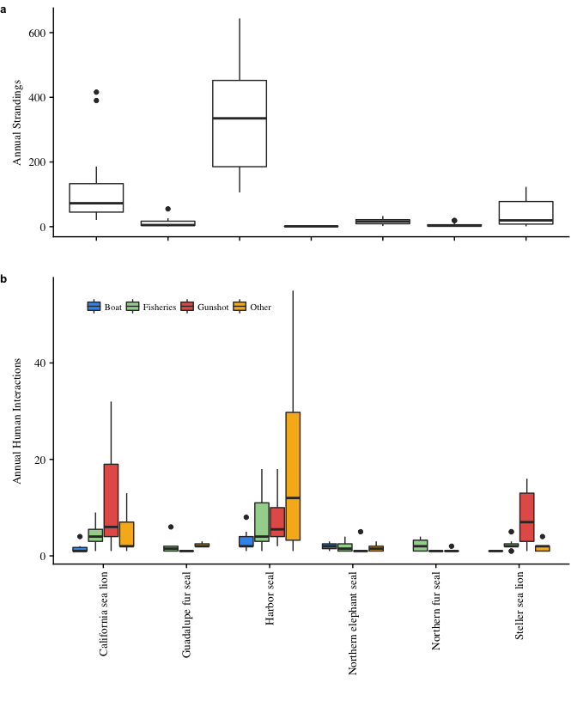

**Figure 1**: Boxplots of (a) total strandings by species and (b) human interactions by case type, with the median annual number indicated by the horizontal black bar.

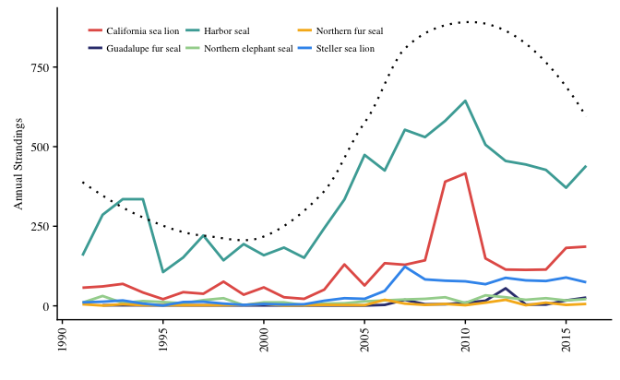

**Figure 2**: Increasing total reported strandings across all species (*n* = 14,729) (black dotted loess regression line) and increasing for harbor seals (y = 1.045x, z = 4.6, *p* < 0.001), California sea lions (y = 1.077x, z = 5.1, *p* < 0.001), Steller sea lions (y = 1.127x, z = 6.9, *p* < 0.001), Guadalupe fur seals (y = 1.122x, z = 2.5, *p* < 0.05), and northern fur seals (y = 1.048x, z = 2.2, *p* < 0.05).

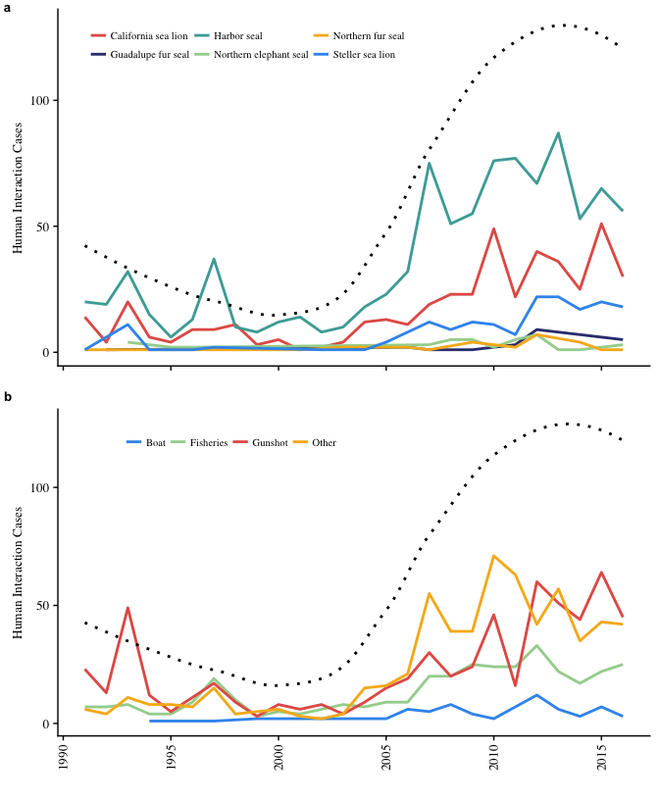

**Figure 3**: (a) Annual HI cases combined (black loess regression line, *n =* 1,652) and for each species illustrate increasing cases for harbor seals (y = 1.073x, z = 4.9, *p* < 0.001), California sea lions (y = 1.075x, z = 4.5, *p* < 0.001), Steller sea lions (y = 1.096x, z = 4.8, *p* < 0.001), and Guadalupe fur seals (y = 1.110x, z = 1.9, *p* < 0.05) and (b) increasing number of gunshot wounds (y = 1.051x, z = 2.8, *p* < 0.001), fisheries entanglements (y = 1.068x, z = 5.9, *p* < 0.001), boat injuries (y = 1.079x, z = 3.1, *p* < 0.001), and “other” cases (y = 1.14x, z = 8.4, *p* < 0.001).

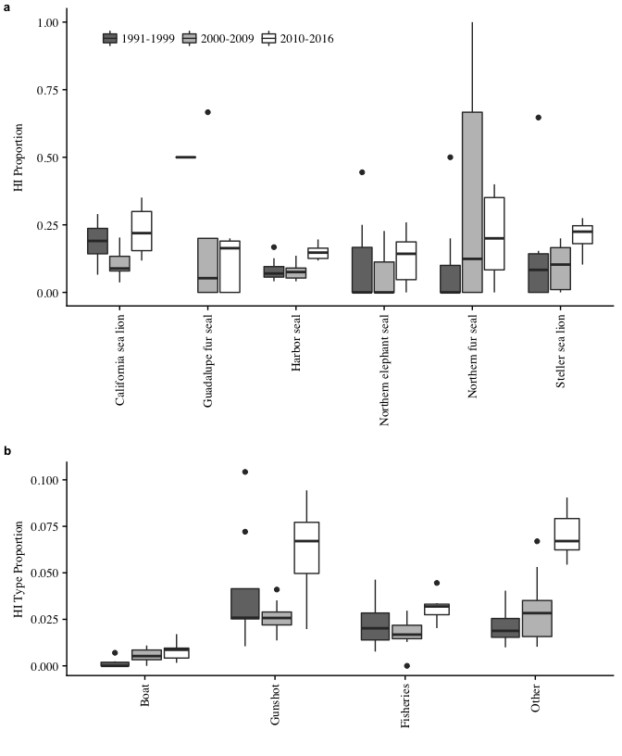

**Figure 4**: Boxplots of annual HI proportion by (a) species and (b) HI case type over three time periods, with the median annual proportion indicated by the horizontal black bar.

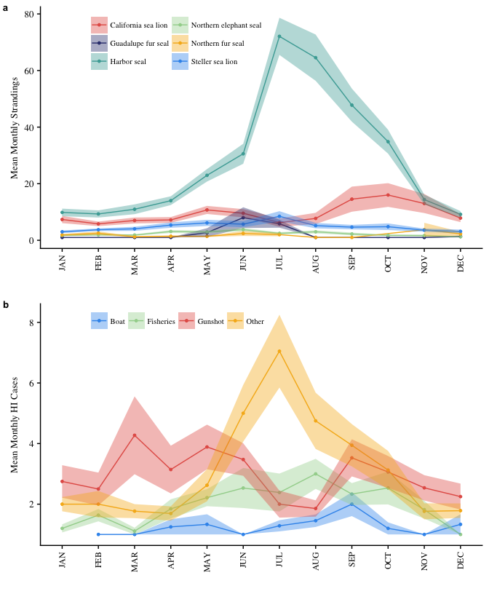

**Figure 5**: Mean number of strandings and human interaction cases and confidence interval bands (± 1 SE of mean) for each month according to (a) species and (b) human interaction type.

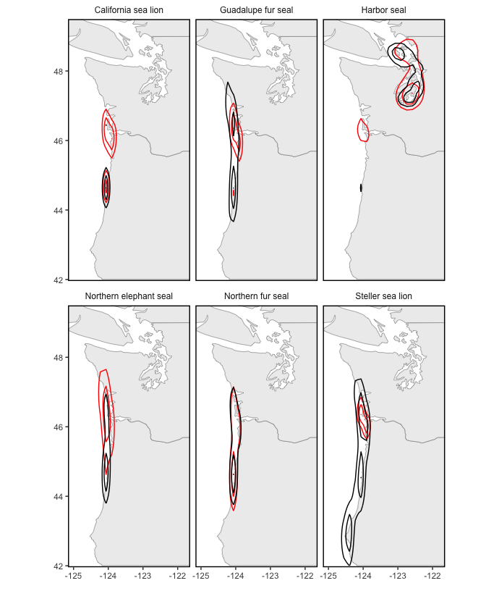

**Figure 6**: Kernel density contour lines showing overlapping hotspots for all strandings (black) and human interaction cases (red) for all species, with hotspots occurring throughout inland Washington waters for harbor seals and along the outer coast near the mouth of the Columbia River for the other species. Kernel density estimation is calculated for each species separately, so contour lines are intended to show the spatial density of each species relative to itself, not compared to others.

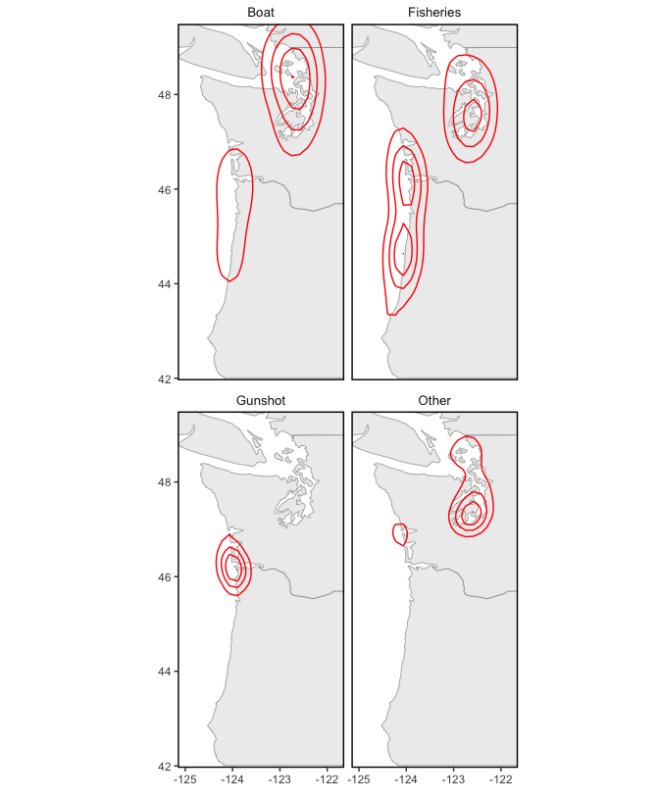

**Figure 7**: Kernel density contour lines showing hotspots of HI cases by type, with fisheries, boat collisions, and other distributed throughout inland Washington waters and at the mouth of the Columbia River, and gunshot wounds centered at the mouth of the Columbia River. Kernel density estimation is calculated for each case type separately, so contour lines are intended to show the spatial density of each type relative to itself, not compared to other case types.

**Table 1**: Age and sex composition and weighted averages of all strandings (*n* = 14,729). Age class composition is derived from the subset of data from 2002-2016 (*n* = 10,861).

|  |  |  |  |  |  |  |  |  |  |  |  |
| --- | --- | --- | --- | --- | --- | --- | --- | --- | --- | --- | --- |
|  | All Strandings | | Sex (% of species) | | | Age (% of species) | | | | | |
| Species | (n) | (%) | Male | Female | Unid. Sex | Pup | Yearling | Subadult | Adult | Unid. Age |
| California sea lion | 2,864 | 19.4 | 78.3 | 1.0 | 20.7 | 0.3 | 10.8 | 17.8 | 64.1 | 7.1 |
| Guadalupe fur seal | 167 | 1.1 | 31.7 | 31.1 | 37.1 | 1.2 | 91.5 | 2.4 | 2.4 | 2.4 |
| Harbor seal | 8,851 | 60.1 | 25.1 | 24.1 | 50.8 | 60.8 | 5.8 | 4.9 | 19.1 | 9.4 |
| Northern elephant seal | 418 | 2.8 | 37.8 | 14.1 | 48.1 | 33.0 | 30.0 | 20.2 | 9.4 | 7.5 |
| Northern fur seal | 119 | 0.8 | 25.2 | 41.2 | 33.6 | 33.7 | 41.3 | 10.9 | 6.5 | 7.6 |
| Steller sea lion | 1,047 | 7.1 | 41.5 | 33.6 | 24.8 | 14.7 | 8.4 | 12.8 | 59.7 | 4.4 |
| Unidentified | 1,263 | 8.7 | 1.9 | 0.7 | 97.4 | 3.4 | 3.0 | 2.1 | 19.4 | 72.0 |
| Average | -- | -- | 35.1 | 18.2 | 46.7 | 39.4 | 9.2 | 8.6 | 31.8 | 11.0 |

**Table 2**: Age and sex composition of all strandings human interaction (HI) cases including those not identified to species, the prevalence of HI (HI cases/all strandings) and the composition of HI cases (HI type/total HI). Age class composition is derived from the subset of data from 2002-2016 (*n* = 10,861).

|  |  |  |  |  |  |  |  |  |
| --- | --- | --- | --- | --- | --- | --- | --- | --- |
|  | All Strandings | | Human Interactions | | HI Composition (% of HI cases) | | | |
| Class | (n) | (% of total) | (n) | (% of class) | Fisheries | Gunshots | Boat Injuries | Other |
| Female | 2,680 | 18.2 | 442 | 16.5 | 19.9 | 32.4 | 5.0 | 42.8 |
| Male | 5,167 | 35.1 | 874 | 16.9 | 16.0 | 47.1 | 4.6 | 32.3 |
| Unid. Sex | 6,882 | 46.7 | 336 | 4.9 | 34.8 | 16.7 | 3.9 | 44.6 |
| Pup | 4,281 | 39.4 | 460 | 10.7 | 17.4 | 4.1 | 6.8 | 71.7 |
| Yearling | 998 | 9.2 | 82 | 8.2 | 39.8 | 20.4 | 4.3 | 35.5 |
| Subadult | 937 | 8.8 | 149 | 15.9 | 22.3 | 52.4 | 4.2 | 21.1 |
| Adult | 3,449 | 31.8 | 583 | 16.9 | 15.8 | 58.5 | 4.3 | 21.4 |
| Unid. Age | 1,196 | 11.0 | 105 | 8.8 | 29.1 | 37.6 | 2.1 | 31.2 |

**Table 3**: Number and composition of all strandings (*n* = 14,729), regional strandings, and human interaction (HI) cases (*n* = 1,652), and the prevalence of HI (HI cases/all strandings) and the composition of HI cases (HI type/total HI).

|  |  |  |  |  |  |  |  |  |  |  |  |  |
| --- | --- | --- | --- | --- | --- | --- | --- | --- | --- | --- | --- | --- |
|  | All Strandings | | Region (%) | | | Human Interactions | | | HI Composition (% of HI cases) | | | |
| Species | (n) | (%) | OR Coast | WA Coast | WA Inland | (n) | (% of species) | Fisheries | | Gunshot | Boat | Other |
| California sea lion | 2,864 | 19.4 | 68.8 | 11.8 | 19.4 | 444 | 15.5 | 18.0 | | 58.8 | 3.4 | 19.8 |
| Guadalupe fur seal | 167 | 1.1 | 60.5 | 34.1 | 5.4 | 24 | 14.4 | 66.7 | | 4.2 | 0.0 | 29.2 |
| Harbor seal | 8,851 | 60.1 | 15.6 | 7.8 | 76.6 | 896 | 10.2 | 19.8 | | 21.4 | 5.7 | 53.1 |
| Northern elephant seal | 417 | 2.8 | 63.7 | 20.2 | 16.1 | 40 | 9.6 | 20.0 | | 30.0 | 10.0 | 40.0 |
| Northern fur seal | 119 | 0.8 | 62.2 | 25.2 | 12.6 | 25 | 21.4 | 72.0 | | 4.0 | 0.0 | 24.0 |
| Steller sea lion | 1,047 | 7.1 | 66.7 | 17.9 | 15.4 | 176 | 16.9 | 15.3 | | 74.4 | 1.7 | 8.5 |
| Unidentified | 1,263 | 8.7 | 67.2 | 5.8 | 27.0 | 47 | 3.7 | 40.4 | | 27.7 | 4.3 | 27.7 |
| Average | -- | -- | 36.2 | 9.9 | 53.9 | -- | 11.2 | 20.9 | | 37.0 | 4.5 | 37.6 |

**Supplemental Information**

**Table S1**: The number and proportion of all strandings and human interaction (HI) cases and the composition of HI cases for each county in Washington (*n* = 9,419).

|  |  |  |  |  |  |  |  |  |
| --- | --- | --- | --- | --- | --- | --- | --- | --- |
|  | All Strandings | | Human Interactions | | HI Composition (% of HI cases) | | | |
| County | (n) | (%) | (n) | (%) | Fisheries | Gunshot | Boat | Other |
| Clallam | 509 | 5.4 | 70 | 6.4 | 30.0 | 27.1 | 4.3 | 38.6 |
| Clark | 8 | 0.1 | 6 | 0.5 | 0.0 | 100.0 | 0.0 | 0.0 |
| Columbia | 1 | 0.0 | 1 | 0.1 | 100.0 | 0.0 | 0.0 | 0.0 |
| Cowlitz | 13 | 0.1 | 7 | 0.6 | 0.0 | 100.0 | 0.0 | 0.0 |
| Grays Harbor | 793 | 8.5 | 117 | 10.6 | 11.1 | 43.6 | 0.0 | 45.3 |
| Island | 835 | 8.9 | 50 | 4.5 | 16.0 | 44.0 | 16.0 | 24.0 |
| Jefferson | 311 | 3.3 | 37 | 3.4 | 24.3 | 13.5 | 5.4 | 56.8 |
| King | 797 | 8.5 | 73 | 6.6 | 28.8 | 26.0 | 0.0 | 45.2 |
| Kitsap | 706 | 7.5 | 79 | 7.2 | 29.1 | 17.7 | 0.0 | 53.2 |
| Mason | 215 | 2.3 | 19 | 1.7 | 26.3 | 21.1 | 0.0 | 52.6 |
| Pacific | 664 | 7.1 | 167 | 15.2 | 16.8 | 68.3 | 0.6 | 14.4 |
| Pierce | 1,354 | 14.5 | 187 | 17.0 | 10.2 | 11.2 | 2.7 | 75.9 |
| San Juan | 1,907 | 20.4 | 85 | 7.7 | 16.5 | 20.0 | 16.5 | 47.1 |
| Skagit | 140 | 1.5 | 22 | 2.0 | 18.2 | 4.5 | 9.1 | 68.2 |
| Snohomish | 286 | 3.1 | 36 | 3.3 | 22.2 | 25.0 | 2.8 | 50.0 |
| Thurston | 307 | 3.3 | 46 | 4.2 | 26.1 | 15.2 | 8.7 | 50.0 |
| Whatcom | 488 | 5.2 | 97 | 8.8 | 7.2 | 17.5 | 11.3 | 63.9 |

**Table S2**: The number and proportion of all strandings and human interaction (HI) cases and the composition of HI cases for each county in Oregon (*n* = 5,310).

|  |  |  |  |  |  |  |  |  |
| --- | --- | --- | --- | --- | --- | --- | --- | --- |
|  | All Strandings | | Human Interactions | | HI Composition (% of HI cases) | | | |
| County | (n) | (%) | (n) | (%) | Fisheries | Gunshot | Boat | Other |
| Clackamas | 7 | 0.1 | 3 | 0.5 | 0.0 | 100.0 | 0.0 | 0 |
| Clatsop | 1,008 | 19.1 | 289 | 52.8 | 13.5 | 71.3 | 4.5 | 10.7 |
| Columbia | 5 | 0.1 | 4 | 0.7 | 75.0 | 25.0 | 0.0 | 0.0 |
| Coos | 705 | 13.3 | 41 | 7.5 | 36.6 | 26.8 | 0.0 | 36.6 |
| Curry | 403 | 7.6 | 11 | 2.0 | 27.3 | 45.5 | 0.0 | 27.3 |
| Douglas | 108 | 2.0 | 4 | 0.7 | 25.0 | 50.0 | 0.0 | 25.0 |
| Lane | 371 | 7.0 | 22 | 4.0 | 59.1 | 27.3 | 0.0 | 13.6 |
| Lincoln | 2,180 | 41.2 | 137 | 24.9 | 46.7 | 17.5 | 7.3 | 28.5 |
| Multnomah | 15 | 0.3 | 6 | 1.1 | 16.7 | 83.3 | 0.0 | 0.0 |
| Tillamook | 488 | 9.2 | 33 | 6.0 | 39.4 | 42.4 | 0.0 | 18.2 |



**Figure S1**: Percent difference in the total number of human interaction cases in each county from the mean across all counties from 1991-2016. Points indicate locations of marine mammal stranding networks (MMSN).

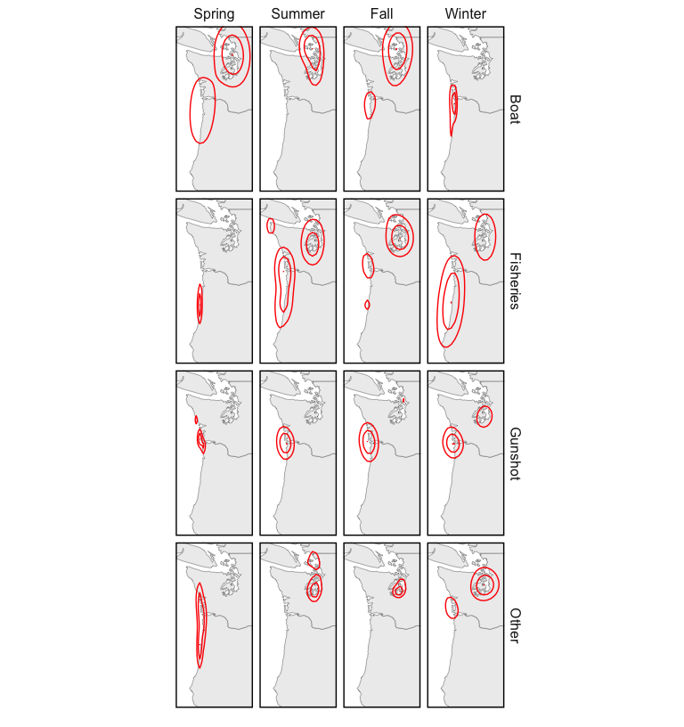 **Figure S2**: Kernel density map of human interaction cases for each season of the year. Kernel density estimation is calculated for each season and HI type separately, so contour lines are intended to show the spatial density of each panel relative to itself, not compared to others.

**Literature Cited**

Aguirre A.A., & Tabor G.M. (2004). Marine vertebrates as sentinels of marine ecosystem health. EcoHealth. 1: 236–238. DOI: 10.1007/s10393-004-0091-9

Antonelis, G.A., Baker, J.D., Johanos, T.C., Braun, R.C., & Harting, A.L. (2006). Hawaiian monk seal (*Monachus schauinslandi*): status and conservation issues. Atoll Research Bulletin 543: 75–101.

Barbieri, M., Raverty, S., Hanson, M.B., Venn-Watson, S., Ford, J.K., & Gaydos, J.K. (2013). Spatial and temporal analysis of killer whale (*Orcinus orca*) strandings in the North Pacific Ocean and the benefits of a coordinated stranding response protocol. Marine Mammal Science 29.4: E448-E462. DOI: 10.1111/mms.12044

Berini, C. R., Kracker, L. M., & McFee, W.E. (2015). Modeling pygmy sperm whale (*Kogia breviceps*) strandings along the southeast coast of the United States from 1992 to 2006 in relation to environmental factors. NOAA Technical Memorandum NOS NCCOS 203. 44 pp.

Bogomolni, A., Pugliares, K.R., Sharp, S.M., Patchett, K., Harry, C.T., LaRocque, J.M., Touhey, K.M., & Moore, M. (2010). Mortality trends of stranded marine mammals on Cape Cod and southeastern Massachusetts, USA, 2000 to 2006. Diseases of Aquatic Organisms 88: 143-155. DOI: 10.3354/dao02146

Bossart, G.D. (2006). Marine mammals as sentinels species for oceans and human health. Oceanography 19(2): 134-37. DOI: 10.5670/oceanog.2006.77.

Bossart, G.D. (2011). Marine mammals as sentinel species for oceans and human health. Veterinary Pathology 48(3): 676-90. DOI: 10.1177/0300985810388525

Brabyn, M. W., & McLean, I. G. (1992). Oceanography and coastal topography of herd stranding sites for whales in New Zealand. Journal of Mammalogy 73: 469–76.

Carretta, J.V., Oleson, E.M., Baker, J., Weller, D.W., Lang, A.R., Baker, J.,… Brownell, R.L. (2016). U.S. Pacific marine mammal stock assessments: 2015. NOAA-TM-NMFS-SWFSC-561. Washington, DC. National Oceanic and Atmospheric Administration.

Colegrove, K.M., Greig, D.J., & Gulland, F.M.D. (2005). Causes of live strandings of northern elephant seals and Pacific harbor seals along the central California coast, 1992-2001. Aquatic Mammals 31(1): 1-10. DOI: 10.1578/AM.31.1.2005.1

DeLong, R.L., Gearin, P.J., Bengston, J.L., Dawson, P., & Feldkamp, S.D. (1990). Studies of the effects of entanglement on individual northern fur seals. In: R.S. Shomura and M.L. Godfrey (eds.), Proceedings of the Second International Conference on Marine Debris, 2–7 April, 1989, Honolulu, Hawaii. NOAA Technical Memorandum NMFS SWFSC 154. pp. 492–493.

DeMaster, D. (2014). Results of Steller sea lion surveys in Alaska, June-July 2013. Memorandum to J. Balsiger, J. Kurland, B. Gerke, and L. Rotterman, NMFS Alaska Regional Office, Juneau AK. Alaska Fisheries Science Center, NMFS, 7600 Sand Point Way NE, Seattle, WA 98115.

Esperon-Rodriguez, M., & Gallo-Reynoso, J.P. (2012). The re-colonization of the Archipelago of San Benito, Baja California, by the Guadalupe fur seal. Revista Mexicana de Biodiversidad 83:170-176.

Evans, K., Thresher, R., Warneke, R., Bradshaw, C.J.A., Pook, M., Thiele, D., & Hindell, M.A. (2005). Periodic variability in cetacean strandings: links to large-scale climate events. Biology Letters 1(2): 147-150. DOI: 10.1098/rsbl.2005.0313

Fowler, C.W. (1987). Marine debris and northern fur seals: a case study. Marine Pollution Bulletin 18: 326–335.

Frungillo, J., & Read, A. (2014). An analysis of gray and harbor seal strandings in Cape Cod, MA from 1999 to 2012. Master’s thesis project, Nicholas School of the Environment of Duke University, NC.

Gatrell, A.C., Bailey, T.C., Diggle, P., & Rowlingson, B.S. (1996). Spatial Point Pattern Analysis and its Application in Geographical Epidemiology, Transactions of the Institute of British Geography 2: 256- 274.

Gelatt, T., Ream, R., & Johnson, D. (2015). *Callorhinus ursinus*. The IUCN Red List of Threatened Species 2015:e.T3590A45224953. <http://www.iucnredlist.org/details/3590/0>

Goldstein, T., Johnson, S.P., Phillips, A.V., Hanni, K.D., Fauquier, D.A., & Gulland, F.M.D. (1999). Human-related injuries observed in live stranded pinnipeds along the central California coast 1986–1998. Aquatic Mammals 25: 43–51.

Greig, D. J., Gulland, F. M. D., & Kreuder, C. (2005). A decade of live California sea lion (*Zalophus californianus*) strandings along the central California coast: Causes and trends, 1991-2000. Aquatic Mammals 31(1): 11-22. DOI: 10.1578/AM.31.1.2005.11

Gulland, F.M.D., & Hall, A.J. (2007). Is marine mammal health deteriorating? Trends in the global reporting of marine mammal disease. EcoHealth 4(2): 135-150. DOI: 10.1007/s10393-007-0097-1

Hanni, K.D., Long, D.J., Jones, R.E., Pyle, P., & Morgan, L.E. (1997). Sightings and strandings of Guadalupe fur seals in central and northern California, 1988-1995. Journal of Mammalogy 78(2): 684-690.

Hanni, K.D., & Pyle, P. (2000). Entanglement of pinnipeds in synthetic materials at south-east Farallon Island, California, 1976–1998. Marine Pollution Bulletin 40: 1076–1081. DOI: 10.1016/S0025-326X(00)00050-3

Huber, H.R., Dickerson, B.R., Jeffries, S.J.& Lambourn, D.M. (2012). Genetic analysis of Washington State harbor seals (*Phoca vitulina richardii*) using microsatellites. Canadian Journal of Zoology 90(12): 1361-1369. DOI: 10.1139/cjz-2012-0047

Huggins, J.L., Leahy, C.L., Calambokidis, J., Lambourn, D., Jeffries, S.J., Norman, S.A., & Raverty, S. (2013). Causes and patterns of harbor seal (*Phoca vitulina*) pup mortality at Smith Island, Washington, 2004-2010. Northwestern Naturalist 94(3): 198-208. DOI: 10.1898/12-14.1

Huggins, J. L., Raverty, S. A., Norman, S. A., Calambokidis, J., Gaydos, J. K., Duffield, D. A., ... Barre, L. (2015a). Increased harbor porpoise mortality in the Pacific Northwest, USA: understanding when higher levels may be normal. Diseases of Aquatic Organisms, 115(2), 93-102. DOI: 10.3354/dao02887

Huggins, J.L, Oliver, J., Lambourn, D.M., Calambokidis, J., Diehl, B. & Jeffries, S. (2015b). Dedicated beach surveys along the central Washington coast reveal a high proportion of unreported marine mammal strandings. Marine Mammal Science 31(2): 782-789. DOI: 10.1111/mms.12184

Jeffries, S.J., P.J. Gearin, H.R. Huber, D.L. Saul, & Pruett, D.A. (2000). Atlas of Seal and Sea Lion haul-out Sites in Washington. Washington Department of Fish and Wildlife, Wildlife Science Division, 600 Capitol Way North, Olympia WA. pp. 150.

Jeffries, S. J., Huber, H. R., Calambokidis, J. & Laake, J. (2003). Trends and status of harbor seals in Washington State: 1978–1999. Journal of Wildlife Management 67:207–218.

Johnston, D.W., Frungillo, J., Smith, A., Moore, K., Sharp, B., Schuh, J. & Read, A. (2015). Trends in stranding and bycatch rates of gray and harbor seals along the Northeastern coast of the U.S.: evidence of divergence in the abundance of two sympatric phocid species? PLoS One 10(7): e0131660.

Kaplan Dau, B., Gilardi, K.V.K., Gulland, F.M., Higgins, A., Holcomb, J.B., St. Leger, J., & Ziccardi, M.H. (2009). Fishing gear-related injury in California marine wildlife. Journal of Wildlife Diseases 45(2): 355-362. DOI: 10.7589/0090-3558-45.2.355

Keledjian, A.J., & Mesnick, S. (2013). The Impacts of El Niño Conditions on California. Sea Lion Fisheries Interactions: Predicting Spatial and Temporal Hotspots along the California Coast. Aquatic Mammals 39(3), 221-232. DOI: 10.1578/am.39.3.2013.221

Kiyota, M. & Baba, N. (2001). Entanglement in marine debris among adult female northern fur seals at St. Paul Island, Alaska in 1991–1999. Bulletin of the National Research Institute of Far Seas Fisheries 38: 13-20.

Kreuder, C., Miller, M.A., Jessup, D.A., Lowenstine, L.J., Harris, M.D., Ames, J.A., Carpenter, T.E., Conrad, P.A., & Mazet, J.A. (2003). Patterns of mortality in southern sea otters (*Enhydra lutras nereis*) from 1998–2001. Journal of Wildlife Diseases 39:495–509. DOI: 10.7589/0090-3558-39.3.495

Kulldorff, M., & Nagarwalla, N. (1995). Spatial disease clusters: Detection and inference. Statistical Methods 14:799–810.

Kulldorff, M. (2001). Prospective time periodic geographical disease surveillance using a scan statistic. Journal of Royal Statistical Society 164(1): 61-72.

Kulldorff, M., Heffernan, R., Hartman, J., Assuncao, R., & Mostashari, F. (2005). A space-time permutation scan statistic for disease outbreak detection. PLoS Med 2(3): e59.

Lambourn, D.M., Garner, M., Ewalt, D., Raverty, S., Sidor, I., Jeffries, S. Rhyan, J., & Gaydos, J.K. (2013). *Brucella pinnipedialis* infections in Pacific harbor seals from Washington State, USA. Journal of Wildlife Disease 49(4): 802-815. DOI: 10.7589/2012-05-137.

Lambourn, D., D’Agnese, E., Jeffries, S., Wilkinson, K., Huggins, J., Rice, J., Duffield, D., Smith, W., Grigg, M., & Raverty, S. (2015). Return of the Guadalupe fur seal to the Pacific Northwest: Stranding and sightings. 21st Biennial Conference on the Biology of Marine Mammals. Dec. 13-18. San Francisco, CA.

Leeney, R.H., Amies, R., Broderick, A.C., Witt, M.J., Loveridge, J., Doyle, J., & Godley, B.J. (2008). Spatio-temporal analysis of cetacean strandings and bycatch in a UK fisheries hotspot. Biodiversity and Conservation 17: 2323. DOI: 10.1007/s10531-008-9377-5

Le Boeuf, B.J., Crocker, D.E., Costa, D.P., Blackwell, S.B., Webb, P.M., & Houser, D.S. (2000). Foraging ecology of northern elephant seals. Ecological monographs 70(3): 353-382.

Lea, M.A., Johnson, D., Ream, R., Sterling, J., Melin, S., & Gelatt, T. (2009). Extreme weather events influence dispersal of naïve northern fur seals. Biology Letters 5: 252–257. DOI: 10.1098/rsbl.2008.0643

Lee, K. (2016). Stranding mortality patterns in California sea lions and Steller sea lions in Oregon and southern Washington, 2006 to 2014. Dissertations and Theses. Paper 2995. Portland State University.

London, J.M., Ver Hoef, J.M., Jeffries, S.J., Lance, M.M., & Boveng, P.L. (2012). Haul-out behavior of harbor seals (*Phoca vitulina*) in Hood Canal, Washington. PLoS One 7(6): e38180.

Lowry, M.S. & Forney, K.A. (2005). Abundance and distribution of California sea lions (*Zalophus californianus*) in central and northern California during 1998 and summer 1999. Fishery Bulletin 103:331-343.

Lowry, M.S., R. Condit, B.Hatfield, S.G. Allen, R. Berger, P.A. Morris, B.J. Le Boeuf, & Reiter, J. (2014). Abundance, Distribution, and Population Growth of the Northern Elephant Seal (*Mirounga angustirostris*) in the United States from 1991 to 2010. Aquatic Mammals 40(1): 20-31. DOI: 10.1578/AM.40.1.2014.20

Maldini, D., Mazzuca, L., & Atkinson, S. (2005). Odontocete stranding patterns in the main Hawaiian Islands (1937–2002): how do they compare with live animal surveys? Pacific Science 59, 55–67.

Maniscalco, J.M., Wynne, K., Pitcher, K.W., Hanson, M.B., Melin, S.R., & Atkinson, S. (2004). The occurrence of California sea lions (*Zalophus californianus*) in Alaska. Aquatic Mammals 30(3): 427-433. DOI: 10.1578/AM.30.3.2004.427

Melin, S.R., DeLong, R.L., & Thomason, J.R. (2000). Attendance patterns of California sea lion (*Zalophus californianus*) females and pups during the non-breeding season at San Miguel Island. Marine Mammal Science 16(1): 169-185. DOI: 10.1111/j.1748-7692.2000.tb00911.x

Melin, S. R., DeLong, R. L., & Siniff, D. (2008). The effects of El Niño on the foraging behavior of lactating California sea lions (*Zalophus californianus*) during the non-breeding season. Canadian Journal of Zoology 86: 192-206. DOI: 10.1139/Z07-132

Melin, S.R., Orr, A.J., Harris, J.D., Laake, J.L., & DeLong, R.L. (2010). Unprecedented mortality of California sea lion pups associated with anomalous oceanographic conditions along the central California coast in 2009. California Cooperative Oceanic Fisheries Investigations Report 51: 182-194.

Moore, S.E. (2008). Marine mammals as ecosystem sentinels. Journal of Mammalogy 89(3): 534–540. DOI: 10.1644/07-MAMM-S-312R1.1

Moore, S.E., Lyday, S., Roletto, J., Litle, K., Parrish, J.K., Nevins, H., ... Kell, S. (2009). Entanglements of marine mammals and seabirds in central California and the north-west coast of the United States 2001-2005. Marine Pollution Bulletin. 58: 1045-1051.

National Marine Fisheries Service. (2008). Recovery Plan for the Steller Sea Lion (*Eumetopias jubatus*). Revision. National Marine Fisheries Service, Silver Spring, MD. 325 pp.

National Marine Fisheries Service. (2013). Status Review of The Eastern Distinct Population Segment of Steller Sea Lion (*Eumetopias jubatus*). 144pp. Protected Resources Division, Alaska Region, National Marine Fisheries Service, 709 West 9th St, Juneau, Alaska 99802.

National Oceanic and Atmospheric Administration Marine Debris Program. 2014 Report on the Entanglement of Marine Species in Marine Debris with an Emphasis on Species in the United States. Silver Spring, MD.

Norman, S.A., Bowlby, C.E., Brancato, M.S., Calambokidis, J., Duffield, D., Gearin, P.J.,... Scordino, J. (2004). Cetacean strandings in Oregon and Washington between 1930 and 2002. Journal of Cetacean Research and Management 6:87–99.

Norman, S.A., Huggins, J., Carpenter, T.E., Case, J.T., Lambourn, D.M., Rice, J.,… Klope, M. (2011). The application of GIS and spatio-temporal analyses to investigations of unusual marine mammal strandings and mortality events. Marine Mammal Science 28(3): E251-E266. DOI: 10.1111/j.1748-7692.2011.00507.x

Orr, A.J., Melin, S.R., Harris, J.D., & DeLong, R.L. (2012). Status of the northern fur seal population at San Miguel Island, California during 2010 and 2011. Pp. 41-58, In: Testa, J. W. (ed.), Fur seal investigations, 2010-2011. U.S. Dep. Commer., NOAA Tech. Memo. NMFS-AFSC-241. 77 pp.

Osinga, N., Shahi Ferdous, M.M., Morick, D., Garcia Hartmann, M., Ulloa, J.A., Vedder, L.,… Kuiken, T. (2012). Patterns of Stranding and Mortality in Common Seals (*Phoca vitulina*) and Grey Seals (*Halichoerus grypus*) in The Netherlands between 1979 and 2008. Journal of Comparative Pathology 147(4): 1-16.

Peltier, H., Baagøe H.J., Camphuysen K.C.J., Czeck R., Dabin W., Daniel P.,… Ridoux, V. (2013). The Stranding Anomaly as Population Indicator: The Case of Harbour Porpoise (*Phocoena phocoena*) in North-Western Europe. PLoS One 8(4): e62180.

Pikesley, S.K., Witt, M.J., Hardy, T., Loveridge, J., Loveridge, J., Williams, R., & Godley, B.J. (2012). Cetacean sightings and strandings: evidence for spatial and temporal trends? Journal of the Marine Biological Association of the United Kingdom: 1-12.

Prado, J.H.F, Mattos, P.H., Silva, K.G, & Secchi, E.R. (2016). Long-term seasonal and interannual patterns of marine mammal strandings in subtropical Western South Atlantic. PLoS One 11(1): e0146339.

Pyenson, N.D. (2010). Carcasses on the coastline: measuring the ecological fidelity of the cetacean stranding record in the eastern North Pacific Ocean. Paleobiology 36: 453–480.

R Development Core Team. (2009). R: a language and environment for statistical computing. R Foundation for Statistical Computing, Vienna, Austria. http://www.R-project.org.

Ross, P.S. (2000). Marine mammals as sentinels in ecological risk assessment. Human and Ecological Risk Assessment 6(1): 29–46.

Soulen, B.K., Cammen, K., Schultz, T.F., & Johnston, D.W. (2013). Factors Affecting Harp Seal (*Pagophilus groenlandicus*) Strandings in the Northwest Atlantic. PloS One 8(7): e68779.

Stewart, B.S., & Yochem, P.K. (1987). Entanglement of pinnipeds in synthetic debris and fishing net and line fragments at San Nicolas and San Miguel islands, California, 1978-1986. Marine Pollution Bulletin 18: 336-339.

Stroud, R.K., & Roffe, T.J. (1979). Causes of death in marine mammals stranded along the Oregon coast. Journal of Wildlife Diseases 15(1): 91-97.

Thomas, A.C., Lance, M.M, Jeffries, S.J., Miner, B.G., & Acevedo-Gutiérrez, A. (2011). Harbor seal foraging response to a seasonal resource pulse, spawning Pacific herring. Marine Ecology Progress Series 441:225–239. DOI: 10.3354/meps09370.

Townsend, C.H. (1931). The fur seal of the California islands with new descriptive and historical matter. Zoologica 9: 442-457.

Truchon M.-H., Measures L., L’Herault V., Brethes J.-C., Galbraith P.S., Harvey, M.,… Lecomte, N. (2013). Marine Mammal Strandings and Environmental Changes: A 15-Year Study in the St. Lawrence Ecosystem. PLoS ONE 8(3): e59311. doi:10.1371/journal.pone.0059311.

Wilkinson, D. & Worthy, G. (1999). In: Conservation and Management of Marine Mammals (Twiss, J. R. and R.R. Reeves, eds.). Smithsonian Institute Press, Washington, pp. 396-411.

Woodhouse, C.D. (1991). Marine mammal beachings as indicators of population events. Marine mammal strandings in the United States: proceedings of the second marine mammal stranding workshop. US Dep Commerce., NOAA Technical Report. NMFS 98:111-115. 157pp.

Zenkovich, B. (1998). The northern elephant seal in Oregon: A pupping range extension and onshore occurrence. Notes 87:3.

1. Categories include pup, yearling, subadult, and adult, though the definition of when a pup becomes a yearling has changed over time, obfuscating the distinction between these two categories that could be combined in future analyses.
2. By nature, entanglements from active versus derelict fishing gear cannot be distinguished in stranding data.
3. From 2002-2016, approximately 10% of cases were found alive and left at the site (primarily harbor seals and California sea lions, largely adults, and a mix of female, male, and unidentified sex depending on the region), indicating that they may have been resting. However, these cases may also have been a “true” stranding if they were ill but returned to the water on their own, exemplifying an ongoing challenge in defining a “stranding” event.
4. See <http://www.nmfs.noaa.gov/pr/health/prescott/> for more information.